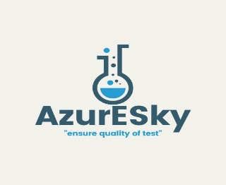 | JOB DESCRIPTION: LABORATORY MANAGER
 | Document no: ASHR 6.2.2 A
Revision no: 00 | Page 1 of 2
Effective Date: July 2025

Roles and Responsibilities:

- Management and productivity task:

- Responsible for ensuring that the laboratory is fully functional.
- Manage sampling, preparation and sample analysis processes and troubleshooting
- Liaising with clients and solving client queries
- Authorization, approval of test results and result evaluation and reporting in accordance with ISO 17043, ISO 17034, ISO 33405 and SANAS R80
- Finalize monthly sample (reference material/certified reference material/ proficiency testing) counts for inventory record keeping and record for sales
- Ensure all tasks are adequately resourced with competent personnel
- Evaluation and implementation of competency training needs to enable efficient, effective and optimal running of the laboratory
- Drive performance management in line with Azuresky policy and address performance challenges and develop subordinates to meet expected performance standards.
- Ensure that laboratory services policies and procedures are constantly reviewed and revised to remain appropriate to current risk exposure.
- Ensure productivity is measured effectively against set objectives to improve customer satisfaction
- Evaluate and recommend equipment needs for the laboratory

- Upholding high quality and safety standards by:

- Maintain laboratory equipment performance by establishing quality standards; develop troubleshooting procedures; ensure staff compliance; recommend equipment replacements, services and repairs
- Ensure compliance with regulatory standards by staying up to date on industry’s best practices and adjusting internal policies as necessary.
- Quality management system implementation and management
- Stock control to ensure required quality and turn-around time is achieved
- Enforce maintenance, calibration and validation of all equipment in use
- Review and align internal procedures to standard methods
- Train staff, schedule work hours and assign projects.
- Transporting of samples (Authorized drivers)
- Responsible for ensuring that control charts are updated and interpreted correctly.
- Enforce housekeeping and ensure compliance to Azuresky safety, health and environmental rules, requirements and systems
- Follow any reasonable instruction from senior management
- Reports to Managing Director or Operation Manager
6. Education & Experience
- Chemistry or related qualification
- 3-5 years’ experience in similar role
- Prior technical signatory appointments are highly advantageous
- Knowledge of ISO 17025,17034 & 17043
- Knowledge of methods & standards related to activities performed in the laboratory.

Declaration by Manager:

I…………………………………………. herby authorize you…………………………to execute the above Roles and Responsibilities as from……/……./ 20….

Declaration by Employee:

By signing below, I……………………………………………herby agree to execute the above Roles and Responsibilities.

……………………….…………. ………………………
Employee Signature Date

